AI-Lab 04 Submission
Name: Yash Raj
Roll No: 24k-0737

Task 01:
Code:

def bfs(graph, start, goal):
visited = []
queue = [[start]]

while len(queue) > 0:
path = queue.pop(0)
node = path[-1]

if node == goal:
return path

if node not in visited:
visited.append(node)

for i in range(len(graph[node])):
if graph[node][i] != 0:
queue.append(path + [i])

return None

def dfs(graph, start, goal):
visited = []
stack = [[start]]

while len(stack) > 0:
path = stack.pop()
node = path[-1]

if node == goal:
return path

if node not in visited:
visited.append(node)

for i in range(len(graph[node])):
if graph[node][i] != 0:
stack.append(path + [i])

return None

def dls(graph, node, goal, limit, path):
if node == goal:
return path

if limit == 0:
return None

for i in range(len(graph[node])):
if graph[node][i] != 0:
result = dls(graph, i, goal, limit - 1, path + [i])
if result is not None:
return result

return None

def ids(graph, start, goal, max_depth):
for depth in range(max_depth + 1):
result = dls(graph, start, goal, depth, [start])
if result is not None:
return result
return None

def ucs(graph, start, goal):
queue = [(start, 0, [start])]
visited = []

while len(queue) > 0:
min_index = 0
for i in range(len(queue)):
if queue[i][1] < queue[min_index][1]:
min_index = i

node, cost, path = queue.pop(min_index)

if node == goal:
return path, cost

if node not in visited:
visited.append(node)

for i in range(len(graph[node])):
weight = graph[node][i]
if weight != 0:
queue.append((i, cost + weight, path + [i]))

return None

graph = [
[0, 1, 4, 0, 0, 0],
[0, 0, 2, 5, 0, 0],
[0, 0, 0, 1, 3, 0],
[0, 0, 0, 0, 0, 2],
[0, 0, 0, 0, 0, 1],
[0, 0, 0, 0, 0, 0]
]

start_node = 0
goal_node = 5

print("BFS:", bfs(graph, start_node, goal_node))
print("DFS:", dfs(graph, start_node, goal_node))
print("DLS (limit=3):", dls(graph, start_node, goal_node, 3, [start_node]))
print("IDS:", ids(graph, start_node, goal_node, 5))
print("UCS:", ucs(graph, start_node, goal_node))

Output:
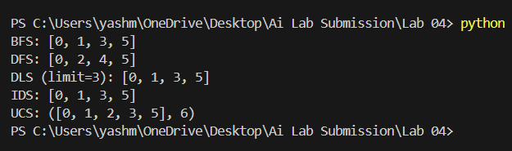

Task 02:
Code:
graph = {
"Arad": [("Zerind", 75), ("Sibiu", 140), ("Timisoara", 118)],
"Zerind": [("Arad", 75), ("Oradea", 71)],
"Oradea": [("Zerind", 71), ("Sibiu", 151)],
"Sibiu": [("Arad", 140), ("Oradea", 151), ("Fagaras", 99), ("Rimnicu", 80)],
"Timisoara": [("Arad", 118), ("Lugoj", 111)],
"Lugoj": [("Timisoara", 111), ("Mehadia", 70)],
"Mehadia": [("Lugoj", 70), ("Drobeta", 75)],
"Drobeta": [("Mehadia", 75), ("Craiova", 120)],
"Craiova": [("Drobeta", 120), ("Rimnicu", 146), ("Pitesti", 138)],
"Rimnicu": [("Sibiu", 80), ("Craiova", 146), ("Pitesti", 97)],
"Fagaras": [("Sibiu", 99), ("Bucharest", 211)],
"Pitesti": [("Rimnicu", 97), ("Craiova", 138), ("Bucharest", 101)],
"Bucharest": []
}

def ucs(start, goal):
queue = [(start, 0, [start])]
visited = []

while len(queue) > 0:

min_index = 0
for i in range(len(queue)):
if queue[i][1] < queue[min_index][1]:
min_index = i

node, cost, path = queue.pop(min_index)

if node == goal:
return path, cost

if node not in visited:
visited.append(node)

for neighbor, weight in graph[node]:
if neighbor not in visited:
queue.append((neighbor, cost + weight, path + [neighbor]))

return None

result = ucs("Arad", "Bucharest")

print("Path:", result[0])
print("Total Cost:", result[1])

Output:
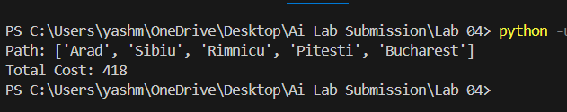

Task 03:
Code:
start_state = (
(7, 2, 4),
(5, 0, 6),
(8, 3, 1)
)

goal_state = (
(0, 1, 2),
(3, 4, 5),
(6, 7, 8)
)

def find_blank(state):
for i in range(3):
for j in range(3):
if state[i][j] == 0:
return i, j

def get_neighbors(state):
neighbors = []
row, col = find_blank(state)

directions = [(-1,0),(1,0),(0,-1),(0,1)]

for dr, dc in directions:
new_row = row + dr
new_col = col + dc

if 0 <= new_row < 3 and 0 <= new_col < 3:

new_state = [list(r) for r in state]

new_state[row][col], new_state[new_row][new_col] = \
new_state[new_row][new_col], new_state[row][col]

neighbors.append(tuple(tuple(r) for r in new_state))

return neighbors

def bfs(start, goal):
queue = [(start, [start])]
visited = set()

while queue:
state, path = queue.pop(0)

if state == goal:
return path

if state not in visited:
visited.add(state)

for neighbor in get_neighbors(state):
if neighbor not in visited:
queue.append((neighbor, path + [neighbor]))

return None

solution = bfs(start_state, goal_state)

print("Total Moves:", len(solution) - 1)
print("Solution Path:")
for step_no, state in enumerate(solution):
print(f"Step {step_no}:")
for row in state:
print(row)
print()

Output:
